Manage Searches has a blank screen in caAERS.
Advanced searches in caAERS enable you to quickly locate information by defining multiple search criteria. You can search for multiple types of data, with multiple values, and apply Boolean Logic (Equal To/Not Equal To, Greater Than/Greater Than or Equal To, Like) to those values, further filtering the search results. For example, if you search for a study under the Study tab, you can only search for studies based on the Identifier OR the Short Title. If you search for a study under the Advanced tab, you could search for a study:
- With a Therapy equal to Behavior AND
- With AE Terminology not equal to CTC AND
- With Subjects of a Gender equal to Male.
All Studies with Male Subjects following Behavior Therapy, using AE Terminology that is not CTC will be selected. The increased flexibility and strength of Boolean logic enables you to find very specific information within caAERS or select larger groups of information which you can then save. You will fill in search criteria, select the columns for the search results, and review the search results. You can also export the search results to an Excel file.
Note: All required fields in caAERS have a red asterisk next to them. This means you must complete the field to save and continue to the next page. Based on the user role assigned to you by the caAERS Administrator and how the product was configured, you may not have access to all the fields and pages described in this topic.

Contents
[hide]
- 1 Filling in Search Criteria
  - 1.1 Filling In Study Information
  - 1.2 Filling In Subject Information
  - 1.3 Filling In Adverse Event Information
  - 1.4 Filling In Report Information
- 2 Selecting the Columns to Include in the Search Results
- 3 Reviewing the Advanced Search Results
- 4 Exporting Advanced Search Results to Microsoft® Excel File
- 5 Managing Advanced Searches

Filling in Search Criteria
The Enter Criteria page enables you to specify the criteria for which you want to perform an advanced search. Based on what you are searching for and the user role assigned to you, you will have the option to fill in different types of search criteria. All the search criteria must be fulfilled for the information to be captured for export.
To access the Enter Criteria page
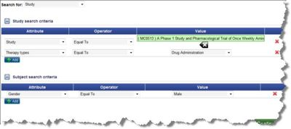
- Click the Advanced Search tab in the navigation bar.
- Click Search, and select the type of item for which you want to search:
  - If you select Study, add information about the study and the subject associated with the study.
  - If you select Subject, add information about the subject and the study.
  - If you select Adverse Event, add information about the adverse event, study, and subject.
  - If you select Report, add information about the report, study, and subject.
- Once you fill in the search criteria:
  - Select the column attributes to be included in the search results.
  - Review the Advanced Search results
  - Export the Advanced Search Results to a Microsoft® Excel file (optional)
  - Manage Advanced Searches (optional)

Filling In Study search criteria Information
To fill in Study Search Criteria on the Enter Criteria page
- Click the plus sign to the left of Study search criteria to expand the study information.
- Select an Attribute.
  - For more information about Study, Short Title, Long Title, and AE Terminology, see Entering Study Details.
  - For more information about Treatment Assignment Code and Treatment Description, see Assigning Treatments.
  - For more information about Therapy Types, see Associating Therapies.
  - For more information about Agents, see Adding Agents.
- Select an Operator:
  - Equal To When the attribute is the same as the Value.
  - Not Equal When the attribute is not the same as the Value.
  - Like When the attribute contains the Value.
- Enter the Value of the attribute (specified in the first column) for which you are searching. The format of the value will vary based on the attribute selected.
- To add another row of search criteria, click Add.
  - Select another Attribute, Operator, and Value.
- To delete a row of search criteria, click the x on the right side of the row.
- When you finish entering search criteria, enter additional types of search criteria as needed, or click Continue to save your search.

Filling In Subject search criteria Information
To fill in Subject Search Criteria on the Enter Criteria page.
- Click the plus sign to the left of Subject search criteria, to expand the study information.
- Select an Attribute to specify the subject information for which to search.
  - Subject ID
  - First Name of the Subject
  - Last Name of the Subject
  - Gender of the Subject
  - Race of the Subject
  - Ethnicity of the Subject
  - Study Subject Identifier A code representing the relationship between the study and the subject.
- Select an Operator:
  - Equal To When the attribute is the same as the Value.
  - Not Equal When the attribute is not the same as the Value.
  - Like When the attribute contains the Value.
- Enter the value of the attribute (specified in the first column) for which you are searching. The format of the value will vary based on the attribute selected.
- To add another row of search criteria, click Add.
  - Select another Attribute, Operator, and Value.
- To delete a row of search criteria, click the x on the right side of the row.
- When you finish entering search criteria, enter additional types of search criteria as needed, or click Continue to save your search.

Filling In Adverse Event search criteria Information
To fill in adverse event information for an Advanced Search
- Click the plus sign to the left of Adverse Event search criteria to expand the study information.
- Select an Attribute (for Adverse Event attributes see Adding Adverse Events).
- Select an Operator:
  - Equal To When the attribute is the same as the Value.
  - Not Equal When the attribute is not the same as the Value.
  - Like When the attribute contains the Value.
  - Greater Than When the date is after the date Value.
  - Greater Than or Equal To When the date is the same as or after the date Value.
- Enter the value of the attribute (specified in the first column) for which you are searching. The format of the value will vary based on the attribute selected.
- To add another row of search criteria, click Add.
  - Select another Attribute, Operator, and Value.
- To delete a row of search criteria, click the x on the right side of the row.
- When you finish entering search criteria, enter additional types of search criteria as needed, or click Continue to save your search.

Filling In Report search criteria Information
To fill in Report Search Criteria for an Advanced Search
- Click the plus sign to the left of Report search criteria, to expand the study information.
- Select an Attribute (for Adverse Event attributes see Entering Report Details).
- Select an Operator:
  - Equal To When the attribute is the same as the Value.
  - Not Equal When the attribute is not the same as the Value.
  - Like When the attribute contains the Value.
  - Greater Than When the date is after the date Value.
  - Greater Than or Equal To When the date is the same as or after the date Value.
- Enter the value of the attribute (specified in the first column) for which you are searching. The format of the value will vary based on the attribute selected.
- To add another row of search criteria, click Add.
  - Select another Attribute, Operator, and Value.
- To delete a row of search criteria, click the x on the right side of the row.
- When you finish entering search criteria, enter additional types of search criteria as needed, or click Continue to save your search.

Selecting the Columns to Include in the Search Results
The Select View page (see Filling in Search Criteria and follow the procedure to this page) enables you to specify what columns to include in the search. Once you fill in the search criteria, the Select View page opens. There are three columns on Select View.
- Search Objects are the items for which you filled search criteria (Study, Subject, Adverse Event, Report).
- Attributes are the data elements associated with the object.
- Selected Attributes are the data that will be listed in a column in the search results.
Note: All the attributes associated with each search object may already be listed in the Selected Attributes, so you can deselect attributes as needed.
To select the view you want for the search results
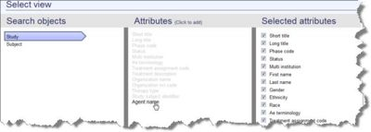
- Click a Search Object in the left column.
- All the attributes associated with the selected object appear in the Attributes column. If you want an attribute to appear as a column in your search results, click the attribute name.
- The attribute name becomes transparent and moves to the Selected Attributes column with a check box next to it. You can add as many attributes as is listed in the middle column. To deselect a Selected Attribute uncheck the box.
- Once you complete the Selected Attributes, click Search.

Reviewing the Advanced Search Results
The results of the Advanced Search display on the Search Results page (see Filling in search criteria and then follow the procedures to this page). Refer to Navigating and Sorting Search Results to sort, navigate, and filter the search results. Once the search results are in the appropriate order, you can export them to a Microsoft® Excel File.
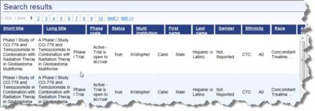

Exporting Advanced Search Results to Microsoft® Excel File
On the Advanced Search Results page (see Filling in Search Criteria and follow the procedures to this page), you can export the list of results to an Excel file. To export the results, just click Export search results... in the upper right corner and follow the prompts.
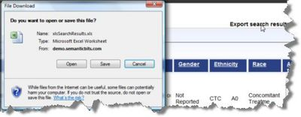

Managing Advanced Searches

